# Sennheiser Strengthens Role in Spectrum Dialogue as Official Audio Partner at the 11th Asia-Pacific Spectrum Management Conference

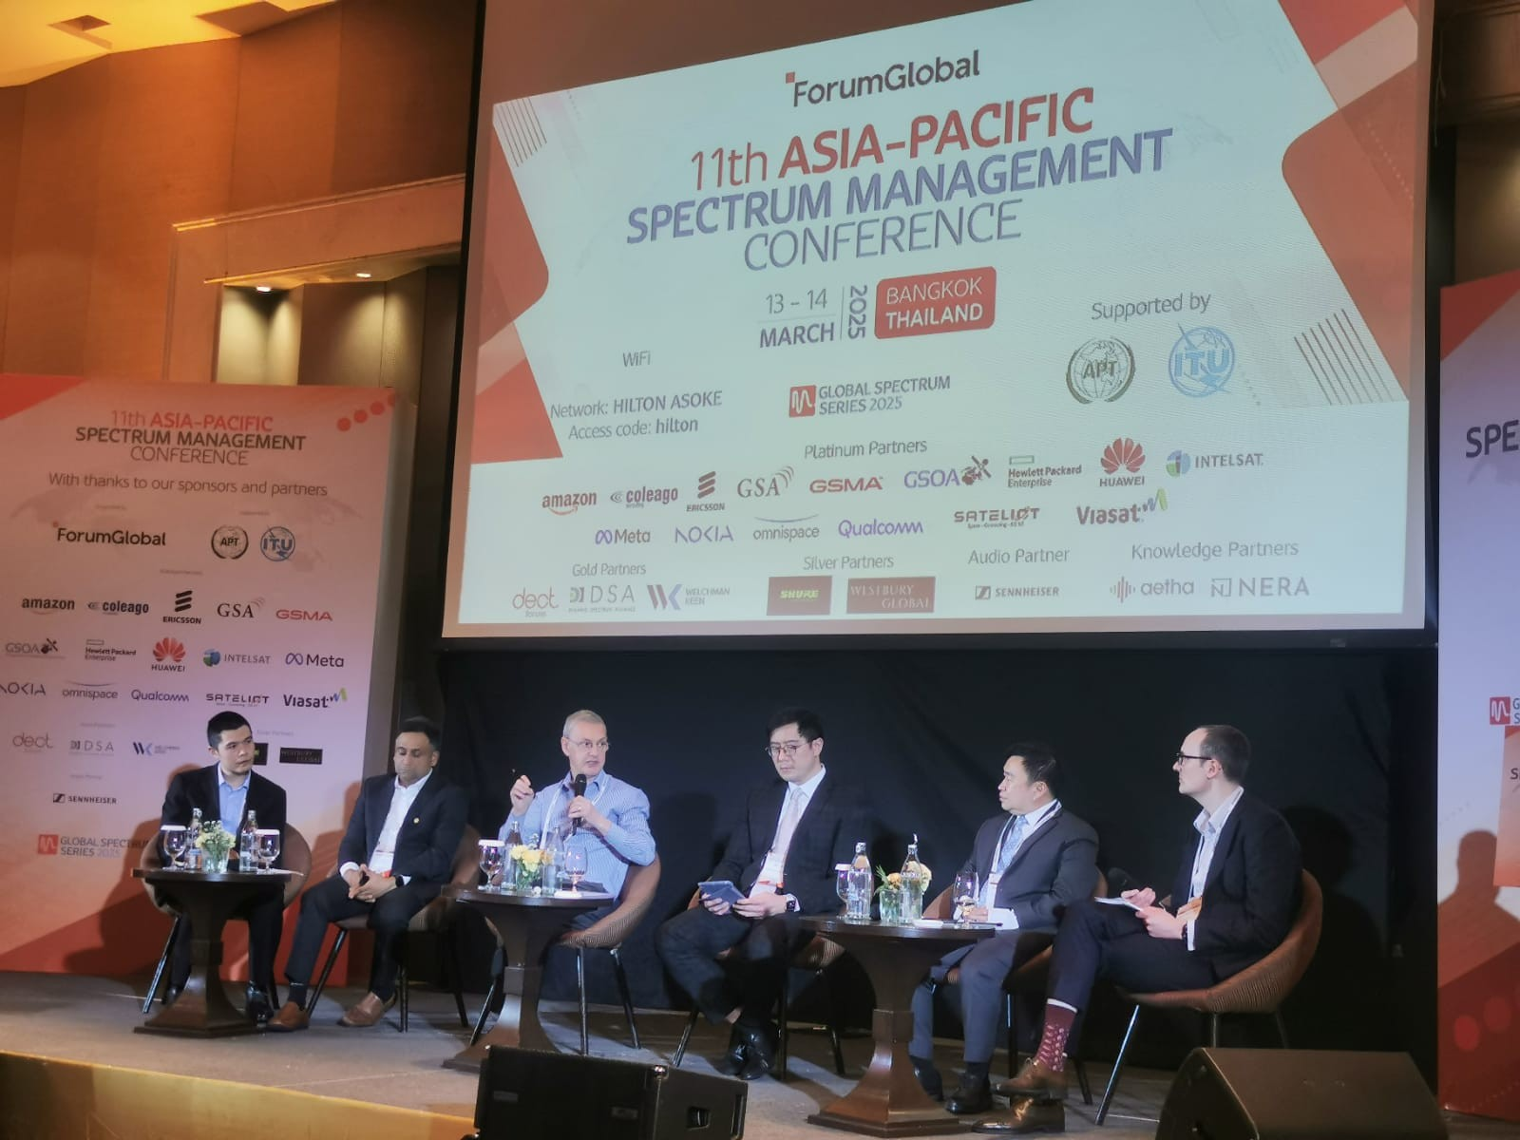

**Sennheiser has proudly participated in the 11th Asia-Pacific Spectrum Management Conference as the Official Audio Partner. Held in Bangkok, Thailand from 13 – 14 March 2025, this event brought together global policymakers, regulators, and industry leaders to address the most pressing spectrum issues shaping the future of wireless communication and connectivity in the Asia-Pacific region. This event is part of The Global Spectrum Series, the world’s largest collection of regional spectrum policy conferences.**

Sennheiser has been an active participant and sponsor of the Asia-Pacific Spectrum Management Conference since 2013, promoting the inclusion of PMSE (Programme Making and Special Events) in spectrum policy dialogues and, more specifically, highlighting the inherent need for allocation of frequency bands to operate wireless microphone systems in the region.

Sennheiser was represented at this year’s conference by Vaughan John, Spectrum Policy and Standards Manager, who contributed to an expert panel discussion, shedding light on the evolving influences of 5G on PMSE. John also shared insights on the “5G Story in Audio PMSE,” highlighting how the new DECT NR+ standard will finally make the promises of 5G towards PMSE come true, and elaborating on the work of the MERCI project.

“As new spectrum policies emerge, it is critical for PMSE to have a voice in the conversation,” said John. “Sennheiser is committed to collaborating with regulators and stakeholders to ensure the needs of the audio industry are included in discussion when developing spectrum policy—especially in regions as diverse and dynamic as Asia-Pacific.”

|  |  |
| --- | --- |
| “DECT NR+ will fulfil the promises that 5G made towards PMSE users,” says Vaughan John, Spectrum Policy and Standards Manager at Sennheiser | Ein Bild, das Menschliches Gesicht, Kleidung, Person, Shirt enthält.  KI-generierte Inhalte können fehlerhaft sein. |

Sennheiser’s involvement in the conference highlights its long-standing engagement with spectrum policy and its ongoing mission to protect and promote spectrum access for wireless microphones and audio PMSE users.

The Asia-Pacific Spectrum Management Conference, organized by Forum Global in partnership with the Asia-Pacific Telecommunity (APT) and the International Telecommunication Union (ITU), featured sessions focused on spectrum harmonization, mid-band deployment, 6G innovation, and regulatory frameworks for satellite and direct-to-device connectivity.

Sennheiser remains dedicated to supporting the global audio community through thought leadership, industry partnerships, and technology solutions that meet the demands of today’s wireless landscape.

**About the Sennheiser brand**

We live and breathe audio. We are driven by the passion to create audio solutions that make a difference. Building the future of audio and bringing remarkable sound experiences to our customers – this is what the Sennheiser brand has represented for more than 75 years. While professional audio solutions such as microphones, meeting solutions, streaming technologies and monitoring systems are part of the business of Sennheiser electronic GmbH & Co. KG, the business with consumer devices such as headphones, soundbars and speech-enhanced hearables is operated by Sonova Holding AG under the license of Sennheiser.

[www.sennheiser.com](http://www.sennheiser.com)

[www.sennheiser-hearing.com](http://www.sennheiser-hearing.com)

**Press Contact**

Phang Su Hui

Suhui.phang@sennheiser.com

M +65 91595024